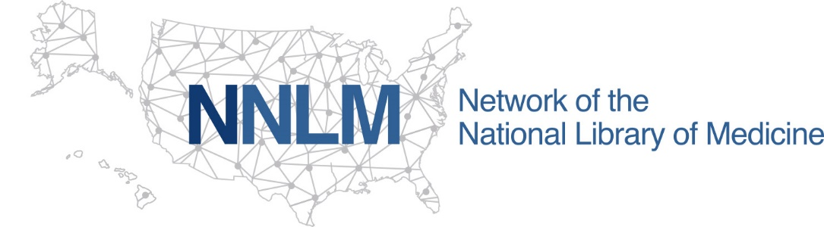

MLA Virtual Conference Registration Award Application

Please complete this application for the MLA Virtual Conference Registration Award Application from NNLM Region 5. All fields need to be completed.

Use this application if you are not able to use the online application form. Completed forms can be emailed to nnlm@uw.edu with the subject line “MLA Virtual Conference Registration Award.”

- Email:

- Name (First and Last):

- Job Title:

- Institution:

- State or Territory where you institution is located:

- To receive funding your organization must be a NNLM Region 5 member. Membership can be confirmed by visiting the NNLM Member Directory. Is your organization a member?
☐ Yes
☐ No (contact ehamstra@uw.edu to become a member)

- Do you work with an underrepresented community as describe in the funding announcement?
☐ Yes
☐ No

- Are you a member of an underrepresented community as described in the funding announcement?
☐ Yes
☐ No
☐ Prefer not to answer

- Describe how attending the virtual MLA Annual Meeting will enhance your ability and skills as a library or health professional. (100-200 words suggested):

- I will share the information gained through a blog post or online meeting held by Region 5. ("Yes" is required to receive the award.)
☐ Yes
☐ No

- I will submit a Professional Development Report as requested by the funding agency & stipulated in the Request for Proposal. ("Yes" is required to receive the award.)
☐ Yes
☐ No

- How did you learn about this award?

Email your completed application to nnlm@uw.edu

