MLA Course Approval Guide
As you apply to get your LIS or iSchool class approved as an MLA consumer health information course, please follow the steps below.
- Contact Sam Nunn at NNLM and Jim Westwood from MLA to notify your interest in applying to get your course approved to become a consumer health information course.

- Email your course syllabus to Jim to review and verify that your course aligns with one or more of the eight CHIS competencies. For more information about the CHIS competencies, visit mlanet.org to learn more.

- Once Jim verifies that your course aligns with one or more of the CHIS competencies, go to https://www.mlanet.org/e/sx/in/eid=64 to submit your course for MLA CE. You will need to have an MLA account to complete the form. To request a free guest account, go to https://www.mlanet.org/r/us/ to get started.

Note that you do not have an MLA membership account to apply. However, if you are interested in becoming a member, visit https://www.mlanet.org/join to learn more.

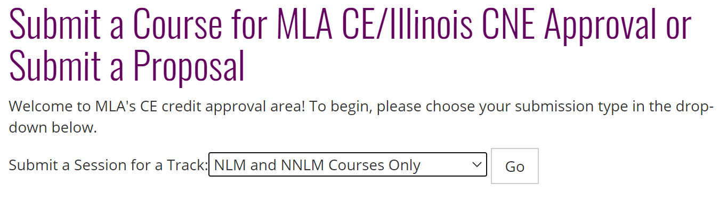
- When choosing the submission type, make sure to select the "NLM and NNLM Courses Only." This selection helps MLA identify if you are taking part in the Consumer Health Library Students program.
- When you have reached the MLA CE Credits section of the form, it will ask you to indicate how many MLA CE hours you seek approval. The CE hours can be determined by the number of hours of in-person work done in the class. One hour of in-person work is equivalent to one CE credit.
MLA CE Credits:  (required) | For how many MLA CE hours are you seeking approval? If you are seeking multiple options depending on your course length, ensure your timed agenda lists specifics for each course length.

- When you have reached the term approval section, it will ask you to indicate how long you would like your course to be eligible for MLA CE. Click the drop-down button and choose "3 years". The program offers to cover all the fees related to having your course offer MLA CE credit for up to 3 years.

Term for approval **:  (required) | Indicate how long you want your course to be eligible for MLA CE approval.  Full fee schedule for approval and listing on MEDLIB-ED are available on MLANET (link opens new tab).

- Throughout the process, please keep in touch with Jim and Sam on the status of your application. If you have any questions about the required information, please contact Jim Westwood or Sam Nunn for assistance.
- Once you've submitted the form, notify both Jim Westwood and Sam Nunn of your completion. MLA will review your application, and a representative will contact you about your submission.

Additional Information for the Future (if application was approved)
If you plan to teach your class again, you will need to fill out a form here to schedule the course on MEDLIB-ED before the semester begins. This form notifies MLA that you are teaching the class again. They will generate a new code for you to give to your future students to claim credit after completing the course.

When you click on the link, it will take you to the "Schedule a Course on the MEDLIB-ED" page. When you click the drop-down button, choose "I am an NLM or NNLM representative scheduling a course" before proceeding to the form.

Once you've submitted the form, MLA will process it and have it listed on their website. An MLA representative might contact you for additional information, if necessary.

